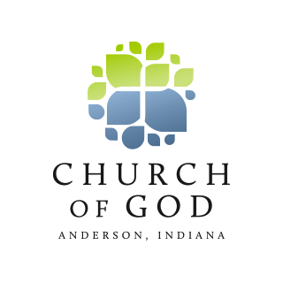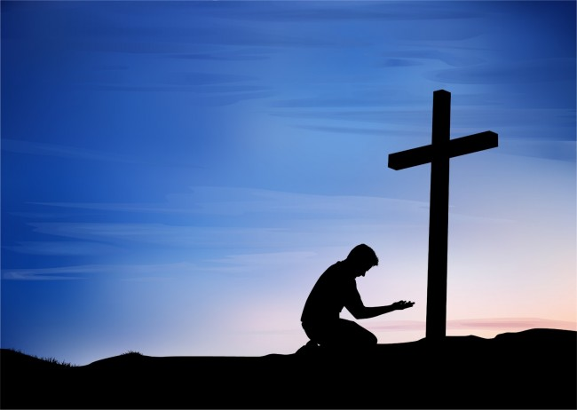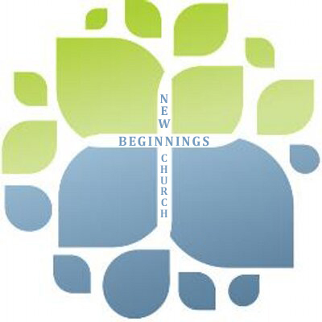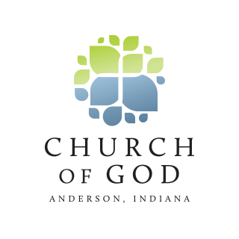

* Vine Life Groups
* Contemporary Services
* Children’s Ministry
* Hope Center
* Veteran’s Outreach
* Youth Ministries
* Missions in Asia

New You

New Life

New Beginnings

New Beginnings Church

## What we do:

333 North Maple Street  
Marysville, Ohio 43040

NewBeginnings4U.org

New Beginnings Church

Marysville, Ohio

**A Church of God**

**Anderson, Indiana Affiliate**

*“Jesus Christ is the subject. Jesus came to change the world. As followers of Jesus Christ, we, too, are called to change the worlds by demonstrating the love of Christ”*

*New Beginnings Church is a faith family committed to reaching the nations with the message of freedom, love and intimacy in Jesus Christ.*

How to face tomorrow, with meaning and purpose, is what we stress at New Beginnings.  The "Good News" that Jesus Christ brings is that there is hope for those needing direction and fulfillment.  We all need faith and friends as we face those inevitable crossroads in life.  We'd love to be your friend and help build your faith.

~Pastors Dan and Shannon Steepe

Thank you for your interest in New Beginnings. 

We chose our name "New Beginnings" for a specific reason.  Sooner or later, everyone needs a new beginning in life.  There is nothing more important at those moments than friends and faith.  We need friends to support and encourage us as well as faith in God to sustain and guide us.  
  
As pastors of the New Beginnings family, we are constantly reminded of how "daily life" can be.  In our various roles we seek significance and meaning, yet too often we come up empty.  Our lives and circumstances have shown us that God has a wonderful plan for life, one that puts all the daily struggles we face into perspective.

# Our Vision

### A Message from our Pastors